**Block Diagram:**

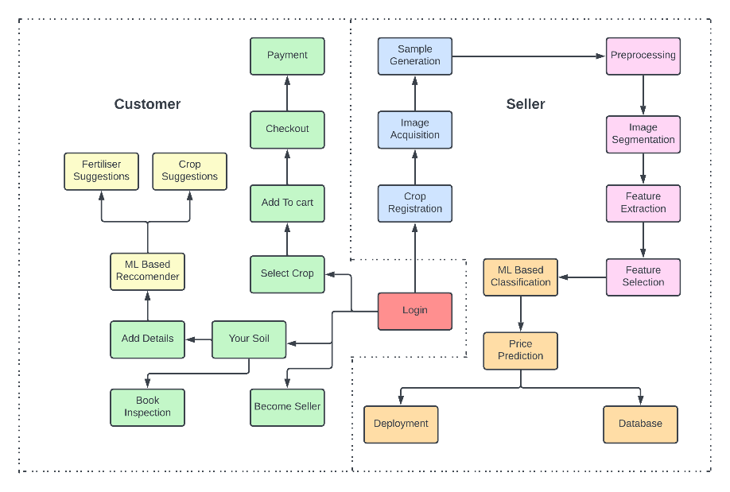

**Use-Case Diagram**

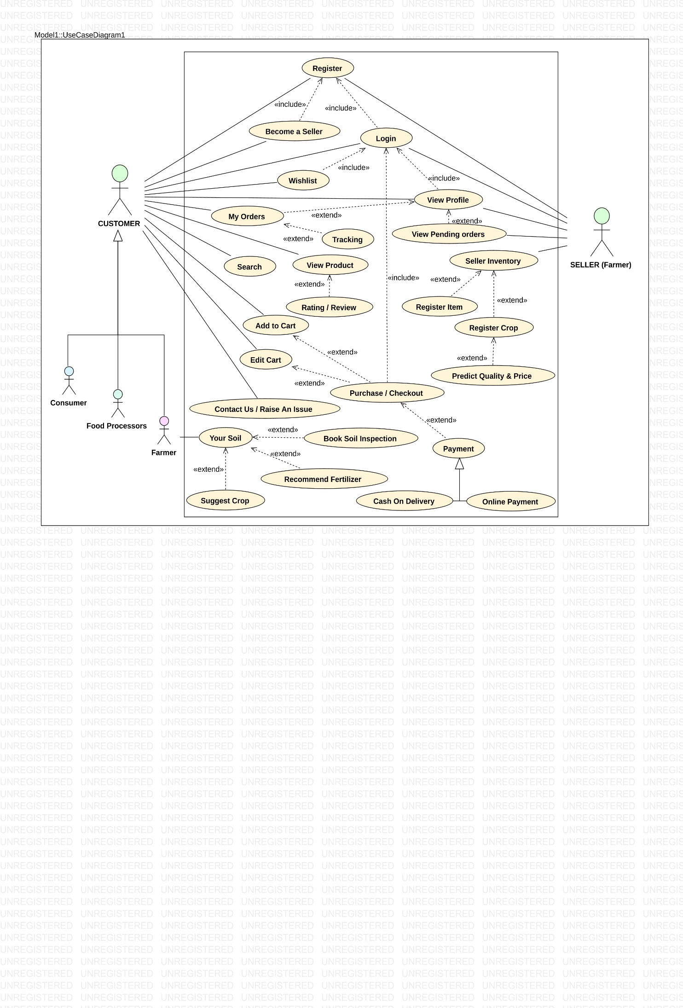

**MVC Architecture**

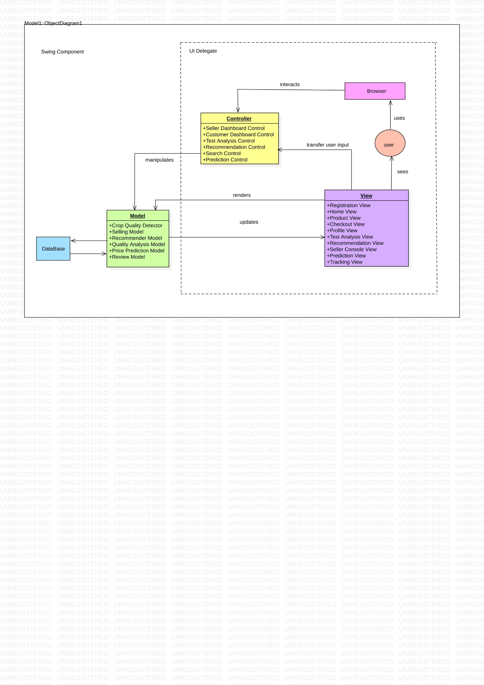

**ER Diagram**

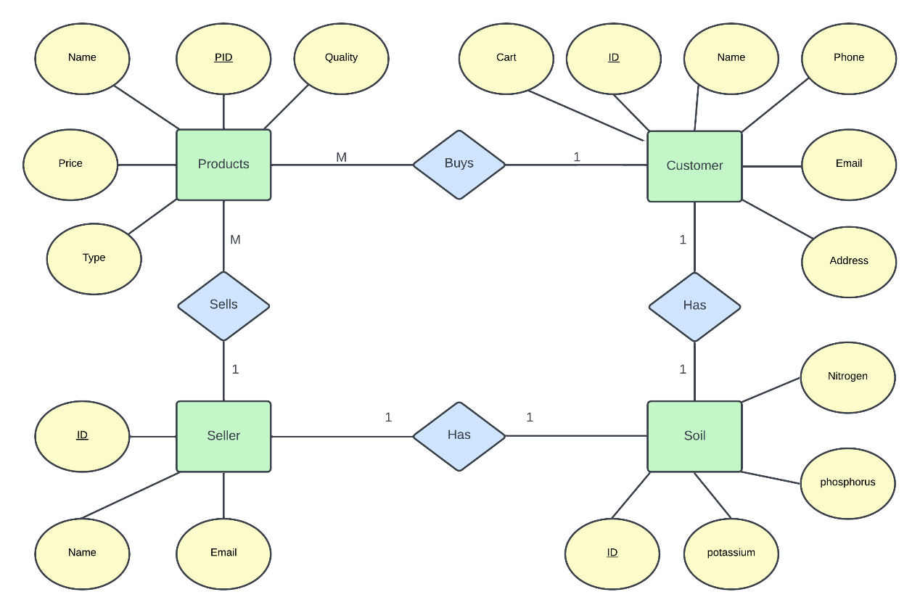

**State Chart Diagrams**

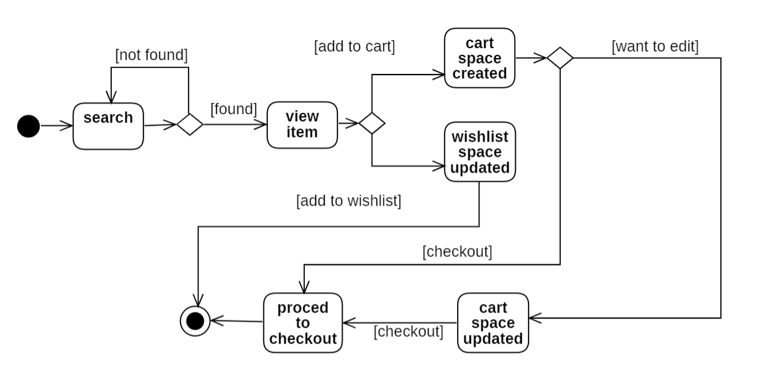

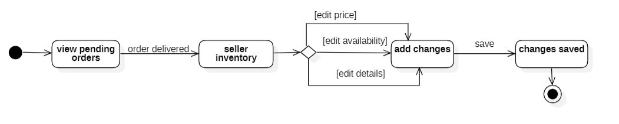

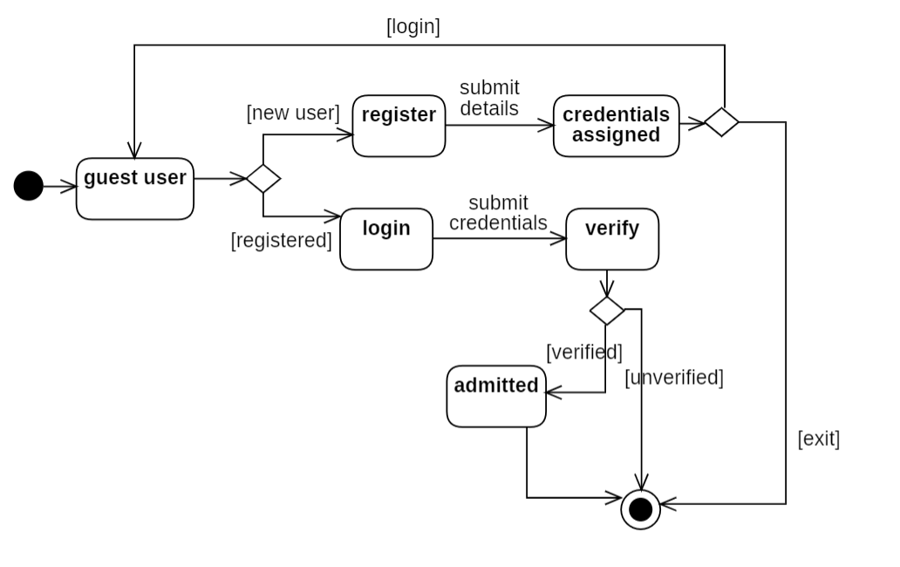

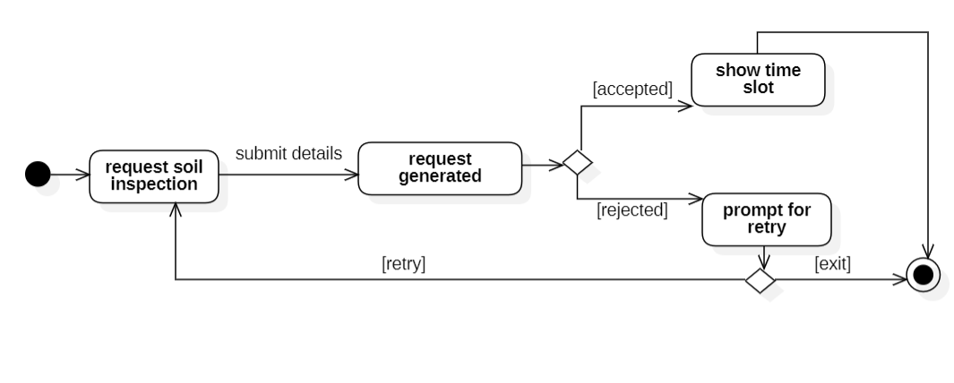

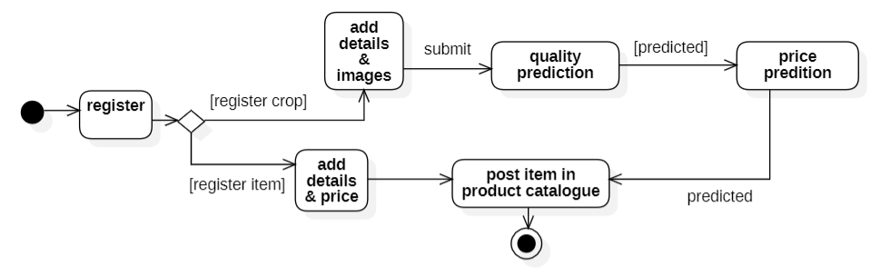

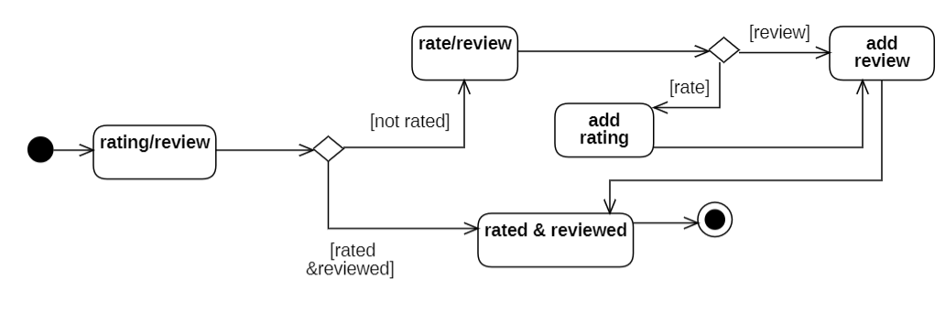

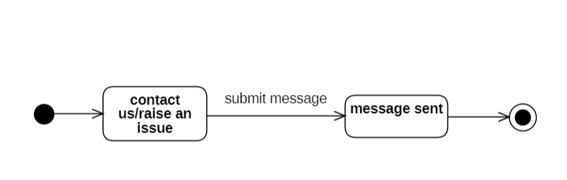

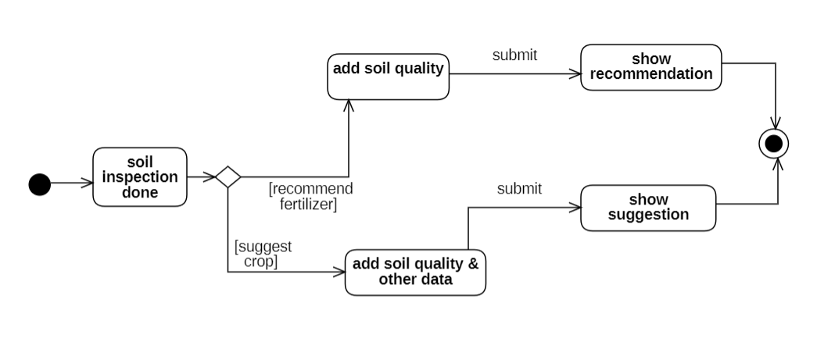

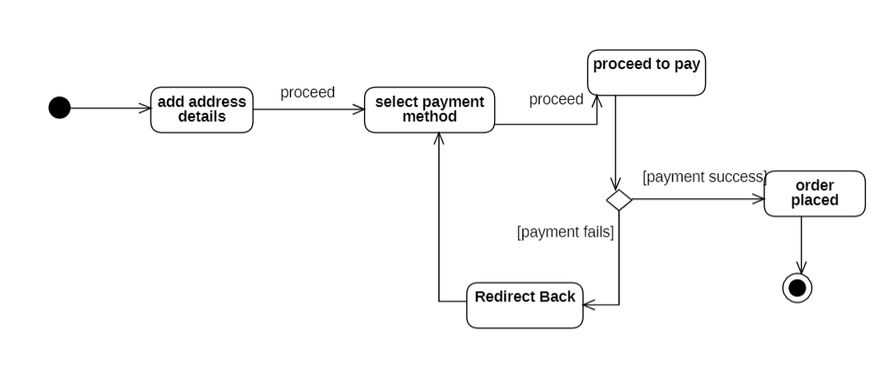

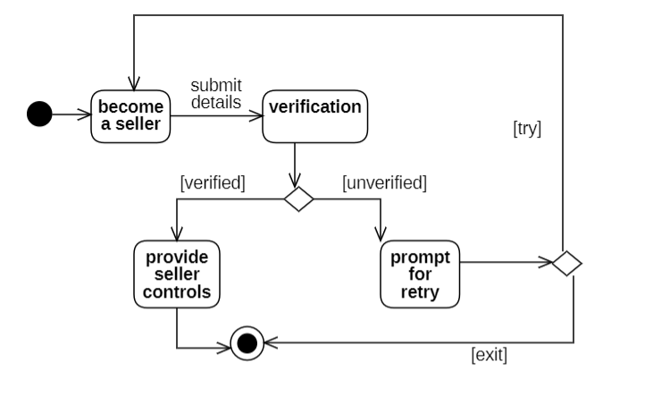

**DATA FLOW DIAGRAMS**

**DFD Level 0**

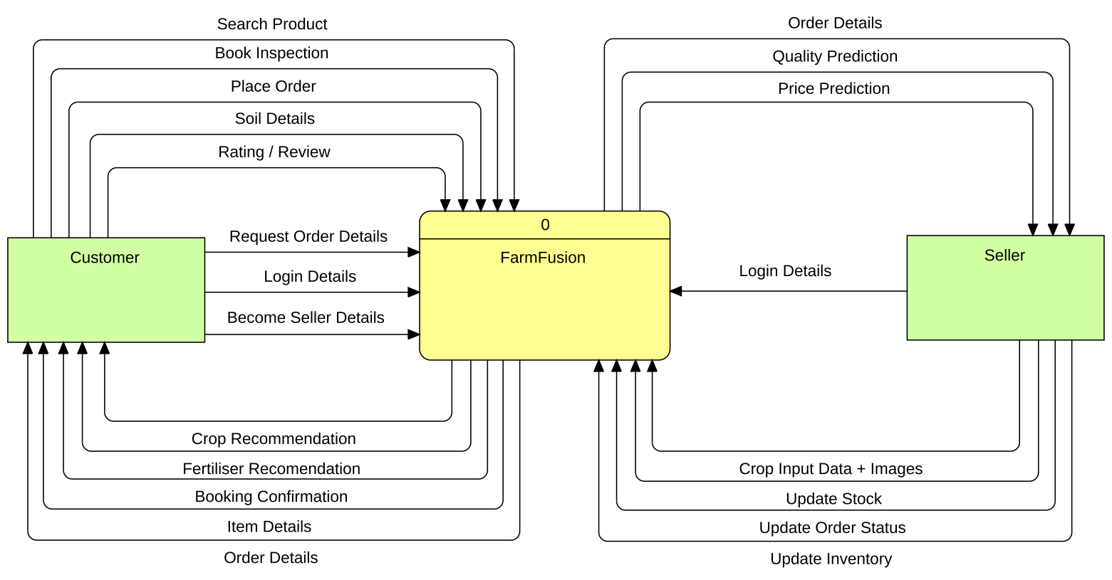

**2.3.2 DFD Level 1**

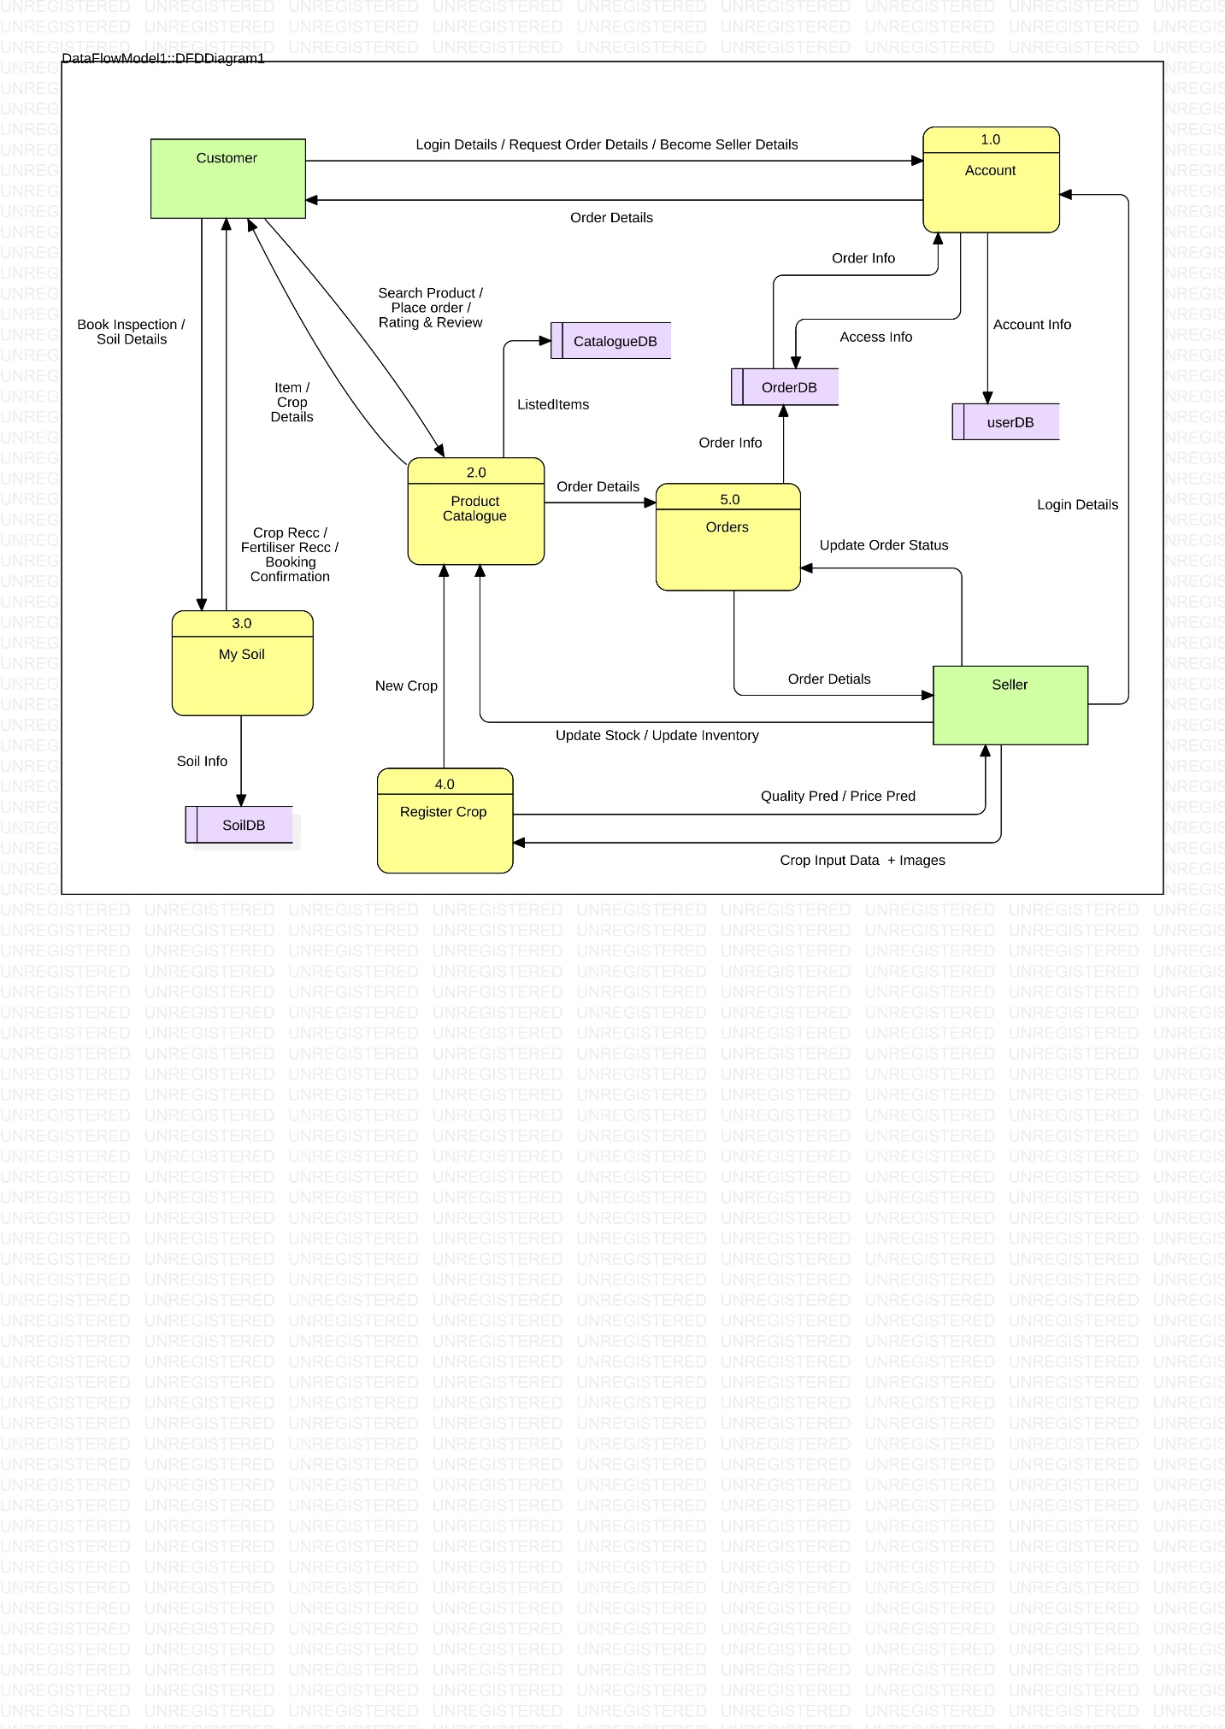

**2.3.3 DFD Level 2:**

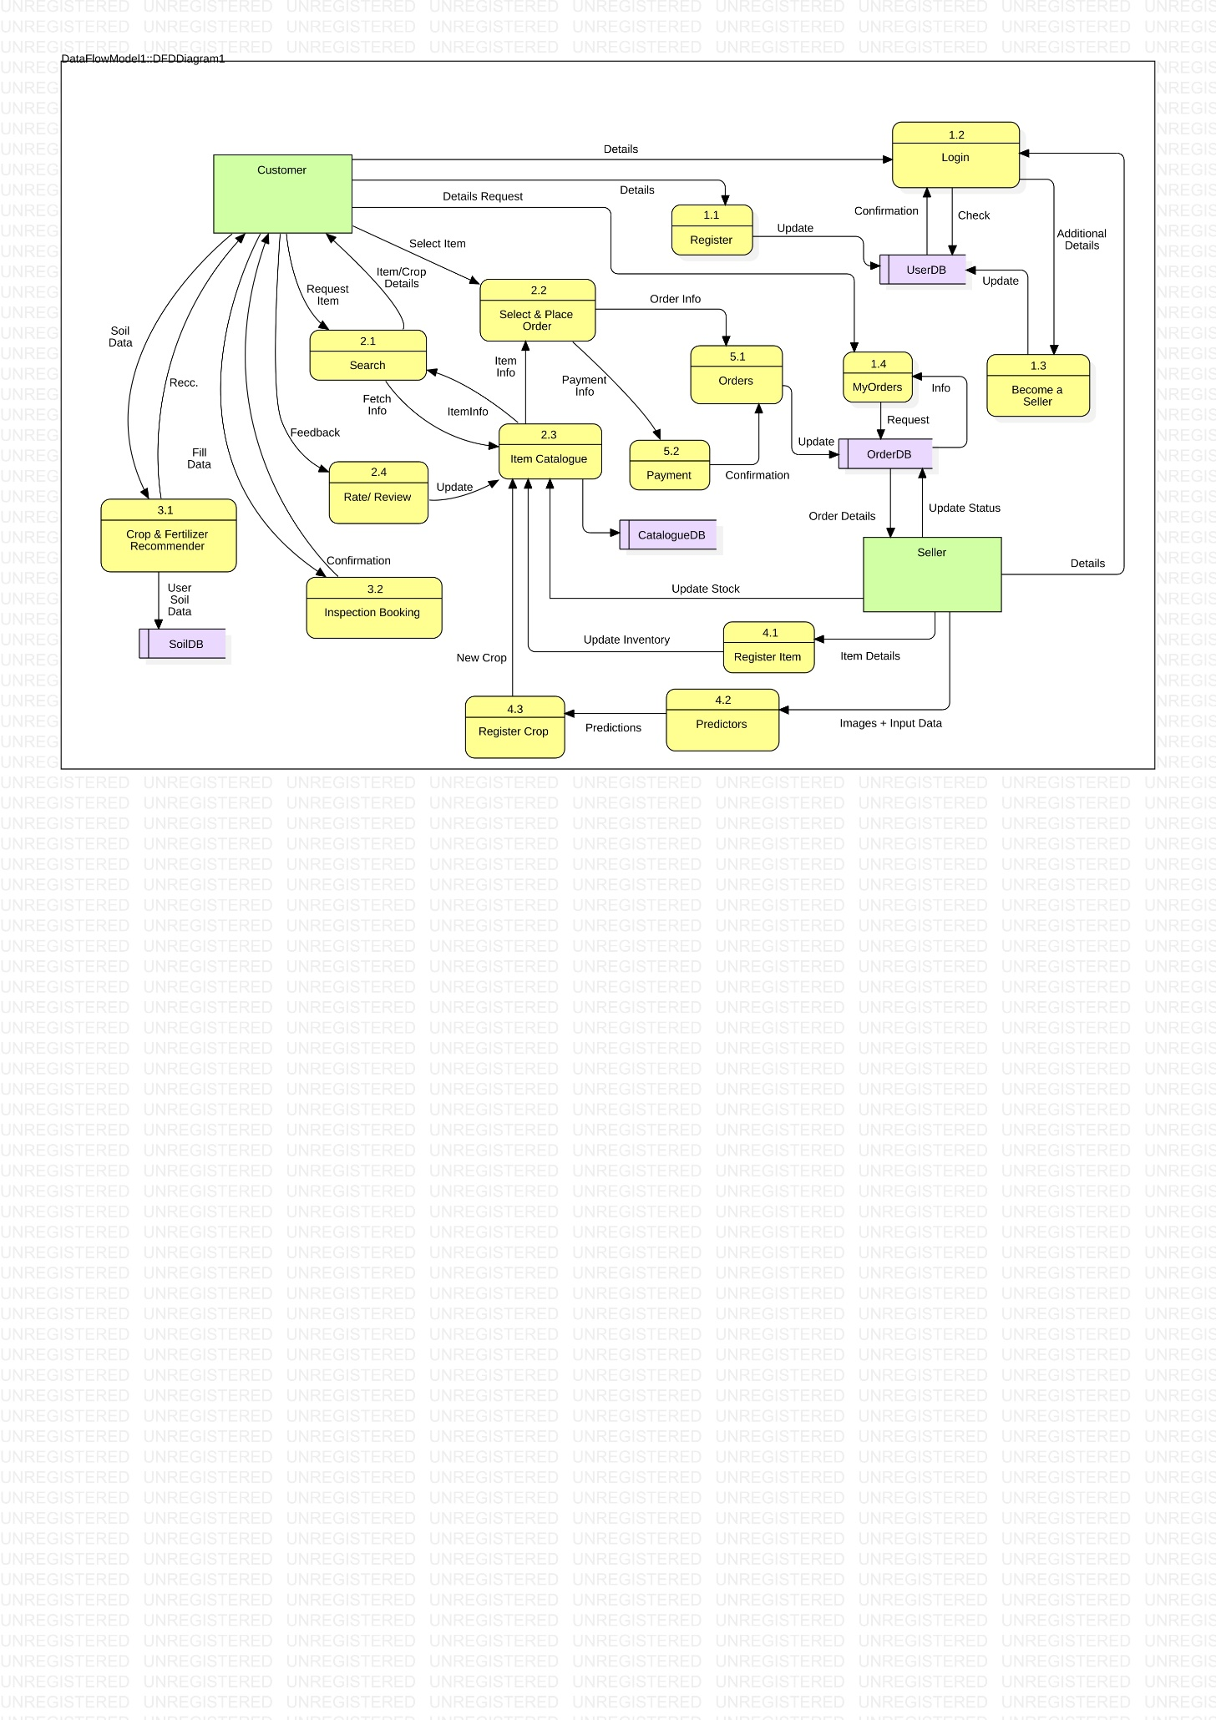

**2.3.3 DFD Level 3:**

**Process 2.2 :**

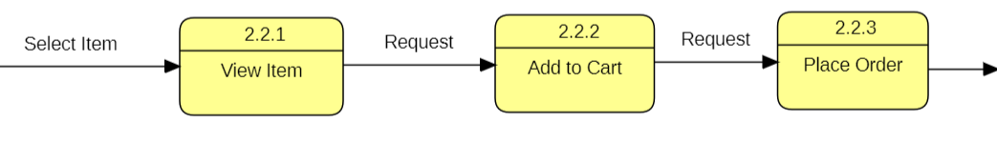

**Process 3.1 :**

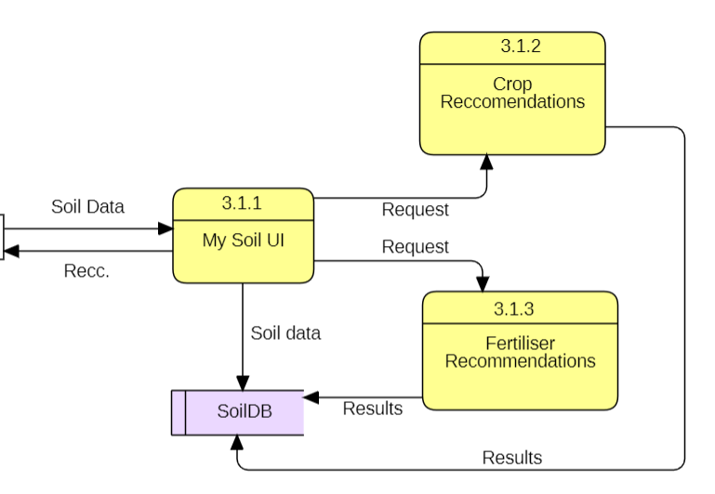

**Process 4.2 :**

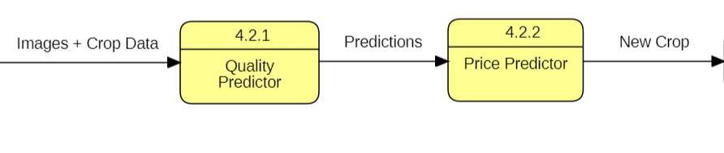

**Class Diagram:**

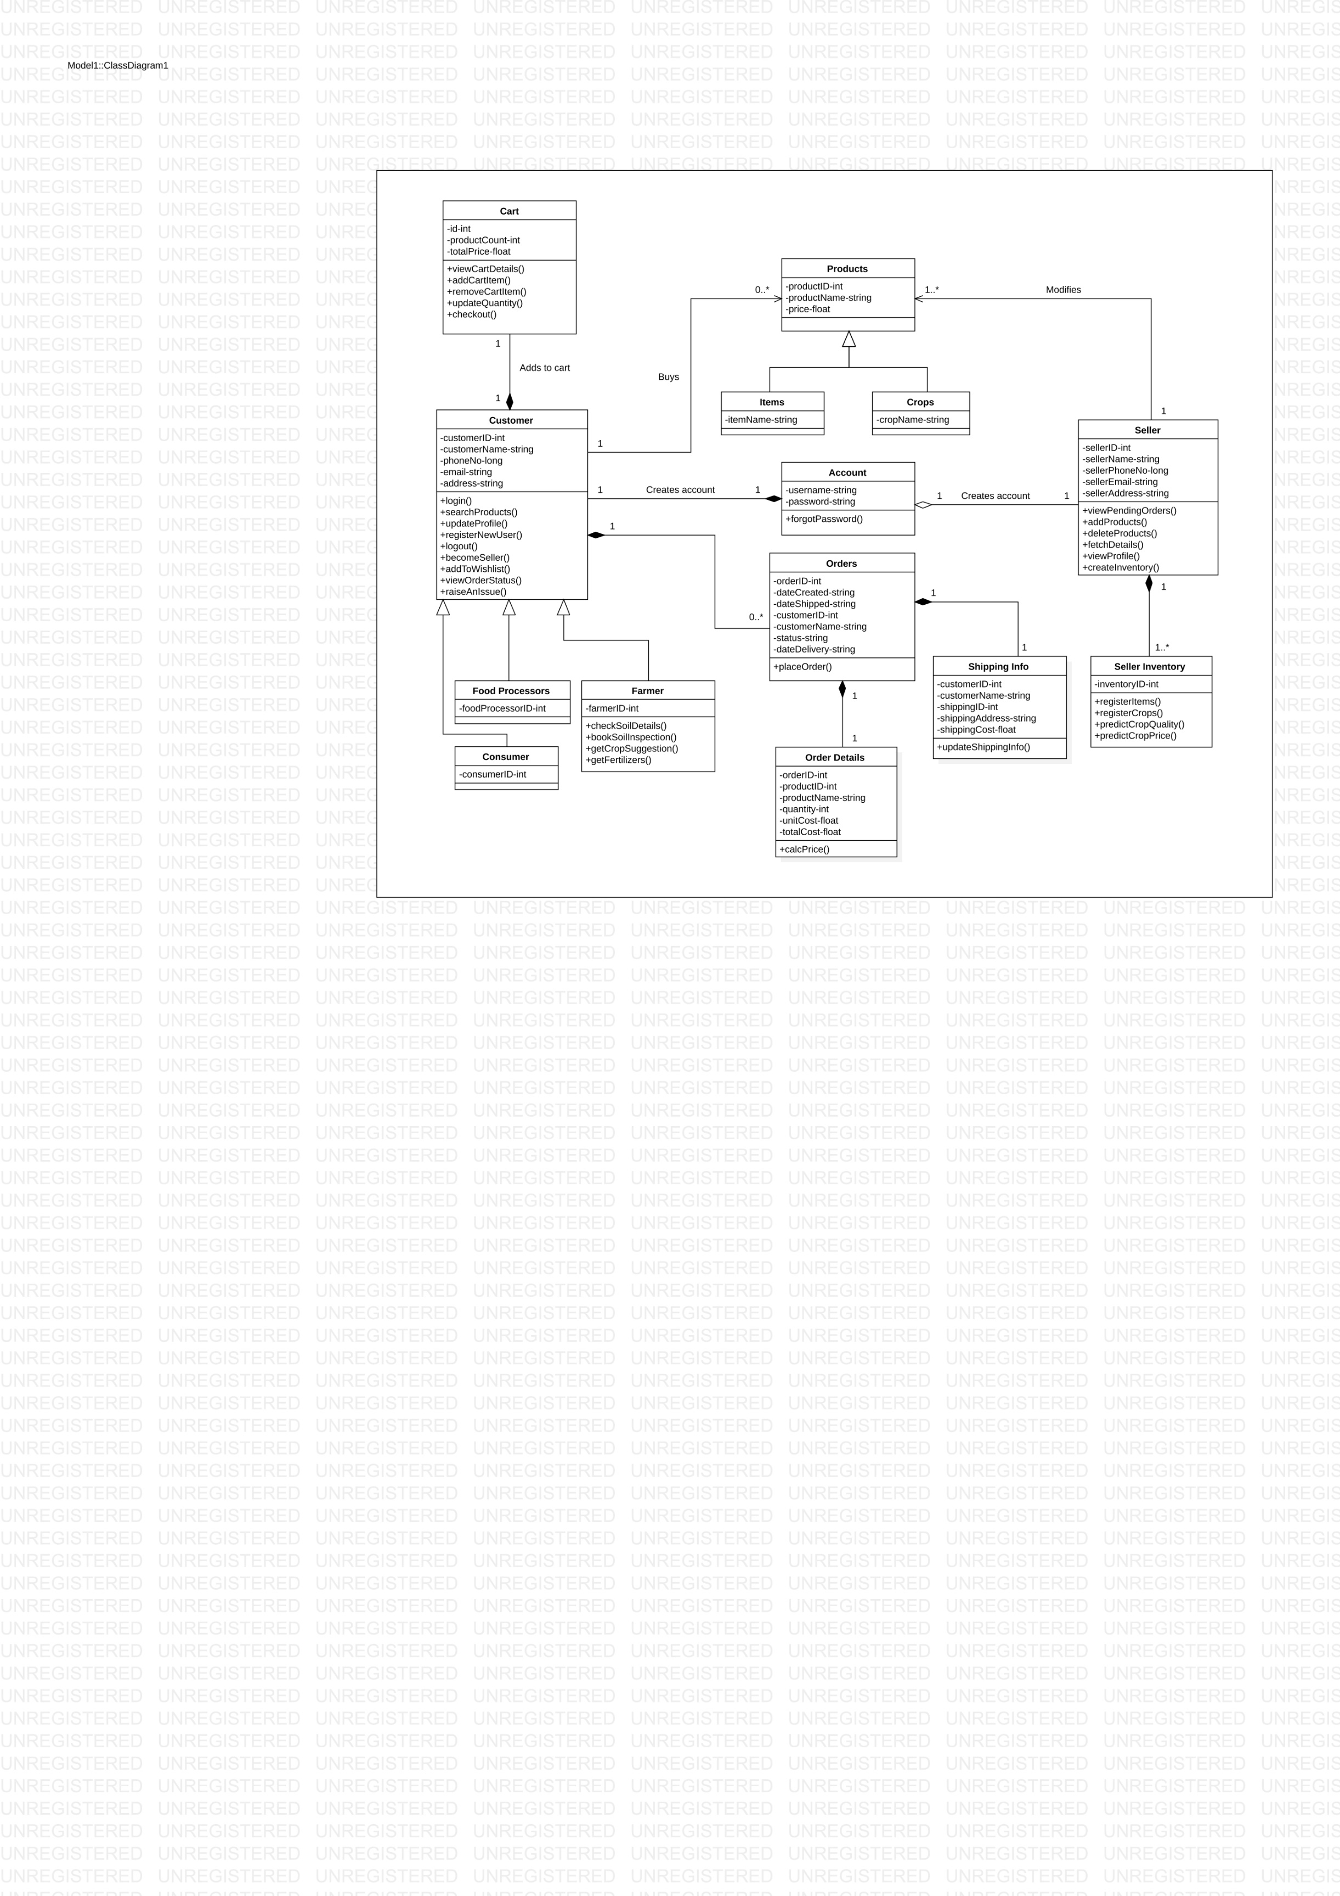

**COMPONENT DIAGRAM**

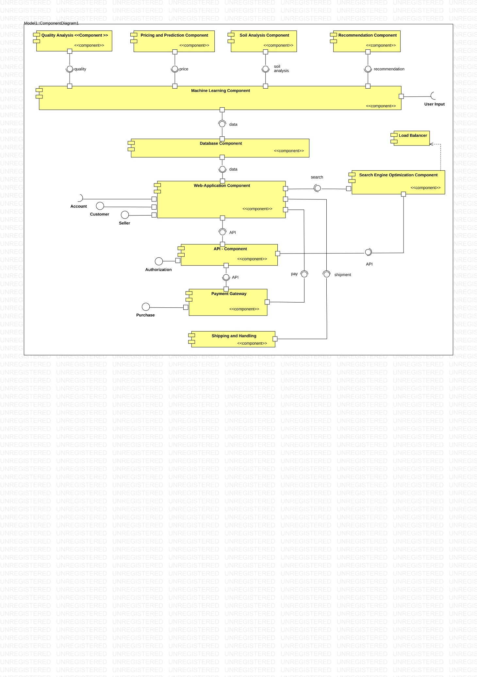

**SWIMLANE:**

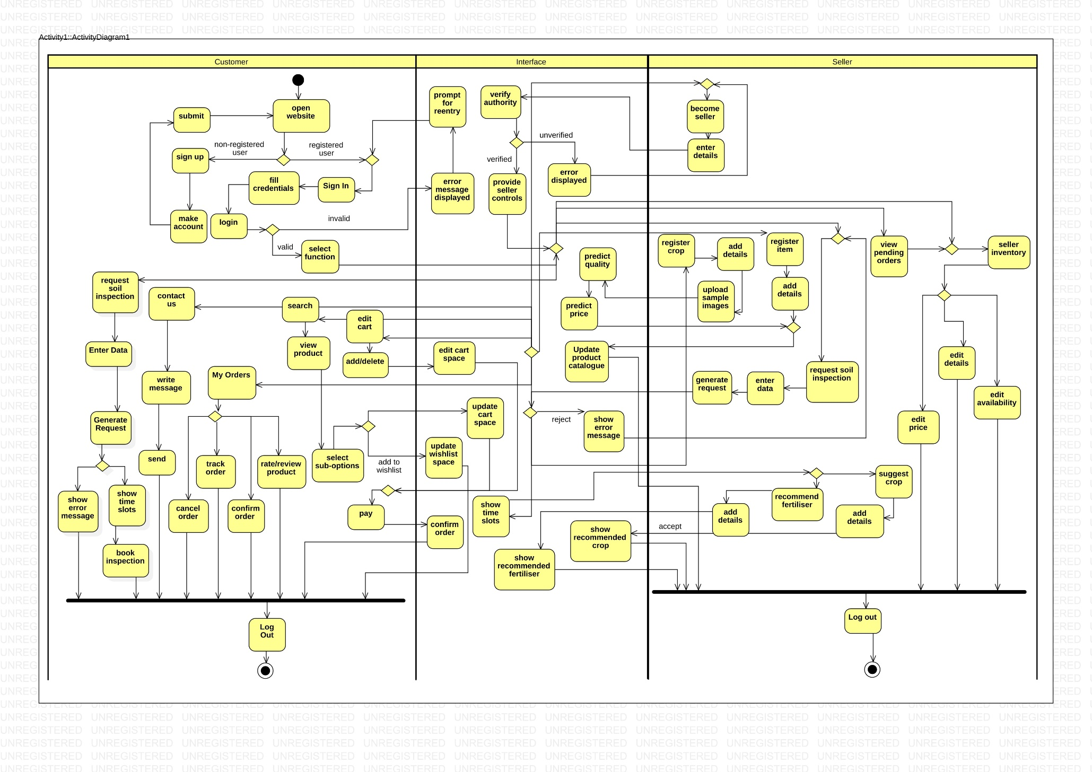

**Cost Analysis:**

For building the soil quality analyzer device we would be using the following components:

1. **Arduino Uno:** This is the main microcontroller board that you will be using to control and manage the different sensors and modules. We would need to write and upload the code to the board to program it to receive data from the NPK sensor and RS485 Modbus module.

Rs. 2100 ([price](https://www.amazon.in/Arduino-UNO-board-DIP-ATmega328P/dp/B008GRTSV6/ref=sr_1_3?crid=7E9SFJXC9P42&keywords=arduino+uno&qid=1683395073&sprefix=arduino+uno%2Caps%2C485&sr=8-3))

1. **Breadboard:** A breadboard is a useful tool for prototyping and testing circuits. We will use it to connect the different components of your project and ensure that they are working properly before soldering them onto a PCB.

Rs. 300-400 ([price](https://www.amazon.in/Iduino-Tie-Points-Breadboard-Connectors-Multicolored/dp/B08PSQ3H7H/ref=sr_1_1_sspa?crid=39BU42OC2CRB5&keywords=breadboard&qid=1683139948&sprefix=breadboa%2Caps%2C241&sr=8-1-spons&sp_csd=d2lkZ2V0TmFtZT1zcF9hdGY&psc=1&smid=A14DHXI99GC1E))

1. **Wires:** We would need wires to connect the different components of your project, such as the NPK sensor and RS485 Modbus module, to the Arduino board. Rs. 100
2. **Arduino Nano Board:** This is a smaller version of the Arduino Uno board that you can use if you need to save space in your project.

Rs. 600-700 ([price](https://www.amazon.in/AUTO-BOTIX-compatible-Arduino-ATmega/dp/B0BG2Y3WMM/ref=sr_1_2?crid=3KOIJB0F34JAL&keywords=Arduino+Nano+Board&qid=1683139667&sprefix=arduino+nano+board%2Caps%2C298&sr=8-2))

1. **RS485 Modbus Module:** This is a communication module that you can use to connect your NPK sensor to the Arduino board. It allows you to send and receive data over long distances using a serial communication protocol.

Rs. 200-350 ([price](https://www.amazon.in/Fertilizer-Resistance-Greenhouse-Agricultural-Production/dp/B08KDRLTTW/ref=sr_1_2?crid=15WQP741Z1UGQ&keywords=npk+sensor&qid=1683139236&sprefix=npk+sensor+%2Caps%2C213&sr=8-2))

1. **Npk sensor:** The NPK sensor is the main sensor in your project that will be used to measure the levels of nitrogen, phosphorus, and potassium in the soil. You will need to connect it to the RS485 Modbus module and write code to read the data from it.

Rs. 6000-6500 ([price](%20https:/www.amazon.in/Fertilizer-Resistance-Greenhouse-Agricultural-Production/dp/B08KDRLTTW/ref=sr_1_2?crid=15WQP741Z1UGQ&keywords=npk+sensor&qid=1683139236&sprefix=npk+sensor+%2Caps%2C213&sr=8-2))

|  |  |
| --- | --- |
| Item | Cost |
| 1. Arduino Uno | 2100 |
| 2.Jumper wires and breadboard | 400 |
| 3. Npk sensor | 6250 |
| 4. RS485 Modbus Module | 300 |
| 5. Arduino Nano Board | 700 |
| 6. Wires | 100 |
| Total cost | 9850 |

**Use Case Templates**

|  |  |
| --- | --- |
| **1. Use Case Title:** | Register |
| **2. Abbreviated Title:** | Register |
| **3. Use Case ID:** | 1 |
| **4. Actors:** | Customer |
| **5. Description:**  New users can register themselves as customers using the Register feature by providing valid login credentials and more personal information and other required details. | |
| **5.1. Pre Conditions:**  1. Customer ID should be unique. | |
| **5.2. Task Sequence:**  1. Click on Sign Up/Register button  2. Fill out all the columns with relevant info.  3. Click on Submit button. | |
| **5.3. Post Conditions:**  1. Customer can now login into his/her account with the registered email. | |
| **6. Modification History:** Date: 5-May-2023 | |
| **7. Author:** Sarthak | |

|  |  |
| --- | --- |
| **1. Use Case Title:** | Login |
| **2. Abbreviated Title:** | Login |
| **3. Use Case ID:** | 2 |
| **4. Actors:** | Customer |
| **5. Description:**  Customers who have already registered can login into their accounts and place orders or maintain carts. | |
| **5.1. Pre Conditions:**  1. Customer should have a registered account. | |
| **5.2. Task Sequence:**  1. Go to the login page.  2. Enter your credentials.  3. Click on login button. | |
| **5.3. Post Conditions:**  1. Customer will be logged into their account if credentials are valid.  2. Error message will be displayed if customer has entered wrong credentials. | |
| **6. Modification History:** Date: 5-May-2023 | |
| **7. Author:** Sarthak | |

|  |  |
| --- | --- |
| **1. Use Case Title:** | View Profile |
| **2. Abbreviated Title:** | View Profile |
| **3. Use Case ID:** | 3 |
| **4. Actors:** | Customer |
| **5. Description:**  View Profile feature allows the customer to view their personal details, past orders, payment  Info , etc. | |
| **5.1. Pre Conditions:**  1. Customer must be logged in to his/her account. | |
| **5.2. Task Sequence:**  1. Login into your account.  2. Click on View Profile button. | |
| **5.3. Post Conditions:**  1. Customer profile page will be displayed. | |
| **6. Modification History:** Date: 5-May-2023 | |
| **7. Author:** Sarthak | |

|  |  |
| --- | --- |
| **1. Use Case Title:** | Search |
| **2. Abbreviated Title:** | Search |
| **3. Use Case ID:** | 4 |
| **4. Actors:** | Customer |
| **5. Description:**  With this search facility, customer can specify any search criteria to apply to products and find  the products he/she needs. | |
| **5.1. Pre Conditions:**  1. Customers must have access to the site. | |
| **5.2. Task Sequence:**  1. Search Bar will be shown on the screen.  2. Type the name or part of the category of the product you want to search for.  3. Click on the search button and you will get desired results. | |
| **5.3. Post Conditions:**  1. Customers can view desired results.  2. Customers can go for another search. | |
| **6. Modification History:** Date: 5-May-2023 | |
| **7. Author:** Sarthak | |

|  |  |
| --- | --- |
| **1. Use Case Title:** | Edit Cart |
| **2. Abbreviated Title:** | Edit Cart |
| **3. Use Case ID:** | 5 |
| **4. Actors:** | Customer |
| **5. Description:**  Edit Cart can allow the customer to modify the quantity of items in the cart or to remove the items from the cart. | |
| **5.1. Pre Conditions:**  1. Customers must be logged in. | |
| **5.2. Task Sequence:**  1. Click on the cart button to land on the edit cart page.  2. Customers can then use the designated buttons like remove from cart, or the quantity button to edit craft | |
| **5.3. Post Conditions:**  1. Customers can purchase the items in the cart.  2. Customers can continue shopping for more items. | |
| **6. Modification History:** Date: 5-May-2023 | |
| **7. Author:** Sarthak | |

|  |  |
| --- | --- |
| **1. Use Case Title:** | Add to cart |
| **2. Abbreviated Title:** | Add to cart |
| **3. Use Case ID:** | 6 |
| **4. Actors:** | Customer |
| **5. Description:**  When a customer finds the product they want, they can add the product to the shopping cart. The system stores and tracks the information about products. | |
| **5.1. Pre Conditions:**  1. Customer should be registered and logged in. | |
| **5.2. Task Sequence:**  1. Customer enter the product to be searched.  2. The system searches the product in the database.  3. If customer find their product they can add it to cart | |
| **5.3. Post Conditions:**  1. Customer can now proceed to payment.  2. Customer can also remove the product from cart | |
| **6. Modification History:** Date: 5-May-2023 | |
| **7. Author:** Vishvam | |

|  |  |
| --- | --- |
| **1. Use Case Title:** | Pay |
| **2. Abbreviated Title:** | Pay |
| **3. Use Case ID:** | 7 |
| **4. Actors:** | Customer |
| **5. Description:**  Using this facility customer can move to checkout and can proceed to payment by selecting  one of the payment options. | |
| **5.1. Pre Conditions:**  Customer should be logged in and have product in cart for payment. | |
| **5.2. Task Sequence:**  1. Customer have to select a payment option.  2. Now they have to verify their details.  3. Confirm their payment. | |
| **5.3. Post Conditions:**  1. If payment was successful then inform the seller.  2.If payment was not successful, inform customer about it and ask them for payment. | |
| **6. Modification History:** Date: 5-May-2023 | |
| **7. Author:** Vishvam | |

|  |  |
| --- | --- |
| **1. Use Case Title:** | Purchase Items |
| **2. Abbreviated Title:** | Purchase Items |
| **3. Use Case ID:** | 8 |
| **4. Actors:** | Customer |
| **5. Description:**  This facility gives customers the facility of selecting a product and adding them to cart and confirming the order and moving towards payment. | |
| **5.1. Pre Conditions:**  Customers should be logged in so that they can add to cart the desired product or can pay for it. | |
| **5.2. Task Sequence:**  1. Customer have to search for their product  2. If they can see the desired product then they have to add the product in cart or can pay | |
| **5.3. Post Conditions:**  1. Customer are allowed to add products to the cart.  2.They can proceed to payment after adding it to the cart. | |
| **6. Modification History:** Date: 5-May-2023 | |
| **7. Author:** Vishvam | |

|  |  |
| --- | --- |
| **1. Use Case Title:** | View pending orders |
| **2. Abbreviated Title:** | View pending orders |
| **3. Use Case ID:** | 9 |
| **4. Actors:** | Seller |
| **5. Description:**  This facility provides sellers with the feature of viewing their pending orders that need to be delivered to the respective customers | |
| **5.1. Pre Conditions:**  1.Seller must be logged in to their dashboard. | |
| **5.2. Task Sequence:**  1. Seller will go to their dashboard.  2. Then they can see their orders which are pending. | |
| **5.3. Post Conditions:**  1. After seeing their pending order if any they have to see their inventory and update it accordingly. | |
| **6. Modification History:** Date: 5-May-2023 | |
| **7. Author:** Vishvam | |

|  |  |
| --- | --- |
| **1. Use Case Title:** | Register Item (fertiliser) |
| **2. Abbreviated Title:** | Register Item |
| **3. Use Case ID:** | 10 |
| **4. Actors:** | Seller |
| **5. Description:**  This facility provides sellers with the feature of adding new item to the product catalogue. | |
| **5.1. Pre Conditions:**  1.Seller must be logged in to their dashboard. | |
| **5.2. Task Sequence:**  1. Seller will go to their dashboard.  2. Click on Add New Item.  3. Add Item details and price.  4. Post the item. | |
| **5.3. Post Conditions:**  1. The Item Gets listed in the website’s product catalogue. | |
| **6. Modification History:** Date: 5-May-2023 | |
| **7. Author:** Vishvam | |

|  |  |
| --- | --- |
| **1. Use Case Title:** | Register Crop |
| **2. Abbreviated Title:** | Register Crop |
| **3. Use Case ID:** | 11 |
| **4. Actors:** | Seller |
| **5. Description:**  This facility provides sellers with the feature of adding new crops to the product catalogue. | |
| **5.1. Pre Conditions:**  1.Seller must be logged in to their dashboard. | |
| **5.2. Task Sequence:**  1. Seller will go to their dashboard.  2. Click on Add New Crop.  3. Add the details of the crop.  4. Upload Sample Images for predictions. | |
| **5.3. Post Conditions:**  1. The Crop gets registered for further predictions. | |
| **6. Modification History:** Date: 5-May-2023 | |
| **7. Author:** Al Sumaim | |

|  |  |
| --- | --- |
| **1. Use Case Title:** | Predict and Post Crop |
| **2. Abbreviated Title:** | Predict and Post Crop |
| **3. Use Case ID:** | 12 |
| **4. Actors:** | Seller |
| **5. Description:**  This facility provides sellers with the feature of publishing new crops after Quality & Price Prediction. | |
| **5.1. Pre Conditions:**  1.Seller must have uploaded the required data inputs for the predictions. | |
| **5.2. Task Sequence:**  1. Seller can see the Quality Prediction calculated by the website after uploading the images.  2. Seller can use the price prediction feature and decide to keep a price within a designated range.  3. Finally the Seller can publish the crop. | |
| **5.3. Post Conditions:**  1. The Crop Gets listed in the website’s product catalogue. | |
| **6. Modification History:** Date: 5-May-2023 | |
| **7. Author:** Al Sumaim | |

|  |  |
| --- | --- |
| **1. Use Case Title:** | Suggest Crop |
| **2. Abbreviated Title:** | Suggest Crop |
| **3. Use Case ID:** | 13 |
| **4. Actors:** | Any User (farmers) |
| **5. Description:**  This facility provides users (farmers) with the feature for getting the suggestions of suitable crops that they can grow. | |
| **5.1. Pre Conditions:**  1.User must be logged in to their dashboard.  2. User has measured the soil quality and uploaded the results in the Add Soil Quality stage. | |
| **5.2. Task Sequence:**  1. User will add the specific details of the soil.  2. Users will click on Get Crop Suggestion. | |
| **5.3. Post Conditions:**  1. The user moves to the next page and gets crops recommended to him/her. | |
| **6. Modification History:** Date: 5-May-2023 | |
| **7. Author:** Al Sumaim | |

|  |  |
| --- | --- |
| **1. Use Case Title:** | Recommend Fertiliser |
| **2. Abbreviated Title:** | Recommend Fertiliser |
| **3. Use Case ID:** | 14 |
| **4. Actors:** | Any User (farmers) |
| **5. Description:**  This facility provides users (farmers) with the feature with which they can get fertiliser suggestions that they can use for improving their soil quality parameters and also the link to buy the fertiliser from the website itself. | |
| **5.1. Pre Conditions:**  1.User must be logged in to their dashboard.  2. User has measured the soil quality and uploaded the results in the Add Soil Quality stage. | |
| **5.2. Task Sequence:**  1. User will add the specific details of the soil.  2. Users will click on Get Fetiliser Suggestion. | |
| **5.3. Post Conditions:**  1. The user moves to the next page and gets ferilisers recommended to him/her. | |
| **6. Modification History:** Date: 5-May-2023 | |
| **7. Author:** Al Sumaim | |

|  |  |
| --- | --- |
| **1. Use Case Title:** | Seller Inventory |
| **2. Abbreviated Title:** | Seller Inventory |
| **3. Use Case ID:** | 15 |
| **4. Actors:** | Seller |
| **5. Description:**  This facility provides sellers with the feature of editing their items in the product catalogue. | |
| **5.1. Pre Conditions:**  1.Seller must be logged in to their dashboard.  2. Seller must have his products registered in the product catalogue. | |
| **5.2. Task Sequence:**  1. Seller will go to their dashboard.  2. Click on My Products.  3. Edit Item details, price and availability.  4. Save the changes | |
| **5.3. Post Conditions:**  1. The Item info gets updated on the website. | |
| **6. Modification History:** Date: 5-May-2023 | |
| **7. Author:** Al Sumaim | |

|  |  |
| --- | --- |
| **1. Use Case Title:** | Order Status/Edit Order |
| **2. Abbreviated Title:** | Order Status/Edit Order |
| **3. Use Case ID:** | 16 |
| **4. Actors:** | Seller / Customer |
| **5. Description:**  This facility provides the users with the feature of checking the details of all the orders placed. In the case of seller , the seller can see the info of pending orders , while the customer can see the same along with features like cancel order , Track Order , Return , Rate / Review , Download Invoice. | |
| **5.1. Pre Conditions:**  1.Seller/Customer must be logged in to their dashboard.  2. The User must have pending orders whose detail that they wish to acquire. | |
| **5.2. Task Sequence:**  1. User will go to their dashboard.  2. Click on My Orders.  3. See The details and perform some given actions / or go back. | |
| **5.3. Post Conditions:**  1. The user comes out of My Orders page to the home screen on the website. | |
| **6. Modification History:** Date: 5-May-2023 | |
| **7. Author:** Meghna | |

|  |  |
| --- | --- |
| **1. Use Case Title:** | Tracking |
| **2. Abbreviated Title:** | Tracking |
| **3. Use Case ID:** | 17 |
| **4. Actors:** | Any User |
| **5. Description:**  This facility provides users with the feature of tracking the package that is ordered . | |
| **5.1. Pre Conditions:**  1.User must be logged in to their dashboard.  2. User must have placed an order. | |
| **5.2. Task Sequence:**  1. User will go to their dashboard.  2. Click on My Orders  3. Select the order which you want the track.  4. Click on Track Package.  5. See the details and Go Back. | |
| **5.3. Post Conditions:**  1. The user goes back to my orders page. | |
| **6. Modification History:** Date: 5-May-2023. | |
| **7. Author:** Meghna | |

|  |  |
| --- | --- |
| **1. Use Case Title:** | Contact Us / Raise An Issue |
| **2. Abbreviated Title:** | Contact Us / Raise An Issue |
| **3. Use Case ID:** | 18 |
| **4. Actors:** | Customer |
| **5. Description:**  This facility provides customers with the feature of raising an issue and contacting the seller by filling the required details. | |
| **5.1. Pre Conditions:**  1.Customer must be logged in to their dashboard. | |
| **5.2. Task Sequence:**  1. Customer will go to their dashboard.  2. Click on Raise a Complaint.  3. Fill up the required details.  4. Click o Send to send the message as an email. | |
| **5.3. Post Conditions:**  1. The user’s message will be sent to the seller. | |
| **6. Modification History:** Date: 5-May-2023 | |
| **7. Author:** Meghna | |

|  |  |
| --- | --- |
| **1. Use Case Title:** | Request Soil Inspection |
| **2. Abbreviated Title:** | Request Soil Inspection |
| **3. Use Case ID:** | 19 |
| **4. Actors:** | Any User |
| **5. Description:**  This facility provides the users with the feature of soil quality testing appointment where our members would visit the spot for testing. | |
| **5.1. Pre Conditions:**  1. Usermust be logged in. | |
| **5.2. Task Sequence:**  1. User will go to their dashboard.  2. Click on Get Soil Checked Button.  3. Enter details about the location and preferred time slot.  4. Request for the Soil Inspection. | |
| **5.3. Post Conditions:**  1. The testing team would visit the location for examination | |
| **6. Modification History:** Date: 5-May-2023 | |
| **7. Author:**  Meghna | |

|  |  |
| --- | --- |
| **1. Use Case Title:** | Become a seller |
| **2. Abbreviated Title:** | Become a seller |
| **3. Use Case ID:** | 20 |
| **4. Actors:** | Customer |
| **5. Description:**  This facility provides user with the feature of becoming a seller on the website. | |
| **5.1. Pre Conditions:**  1. User must be logged in. | |
| **5.2. Task Sequence:**  1. User will go to their dashboard.  2. Click on Become a seller tab  3. Enter details and verify the authority  4. Requests for becoming a seller | |
| **5.3. Post Conditions:**  1. The user would be provided with the seller facility and controls. | |
| **6. Modification History:** Date: 5-May-2023 | |
| **7. Author:** Armandeep | |

|  |  |
| --- | --- |
| **1. Use Case Title:** | Wishlist |
| **2. Abbreviated Title:** | Wishlist |
| **3. Use Case ID:** | 21 |
| **4. Actors:** | Customer |
| **5. Description:**  This facility provides customer to add products to a personalized wishlist to save for later. | |
| **5.1. Pre Conditions:**  1. Customer must be logged in. | |
| **5.2. Task Sequence:**  1. User will go dashboard  2. View a product.  3. Add the product to wishlist. | |
| **5.3. Post Conditions:**  1. The selected item would be added to wishlist. | |
| **6. Modification History:** Date: 5-May-2023 | |
| **7. Author:** Armandeep | |

|  |  |
| --- | --- |
| **1. Use Case Title:** | Rate/Review |
| **2. Abbreviated Title:** | Rate/Review |
| **3. Use Case ID:** | 22 |
| **4. Actors:** | Customer |
| **5. Description:**  This feature provides user the ability to rate and review any product they have purchased. | |
| **5.1. Pre Conditions:**  1. Customer must be logged in.  2. Customer must have purchased the item. | |
| **5.2. Task Sequence:**  1. User will go to their dashboard.  2. View the purchased product.  3. Rate the product.  4. Review the product. | |
| **5.3. Post Conditions:**  1. The selected item would be rated/reviewed. | |
| **6. Modification History:** Date: 5-May-2023 | |
| **7. Author:** Armandeep | |

|  |  |
| --- | --- |
| **1. Use Case Title:** | View Product |
| **2. Abbreviated Title:** | View Product |
| **3. Use Case ID:** | 23 |
| **4. Actors:** | Customer |
| **5. Description:**  This facility provides customer the ability to view and navigate through product catalogue. | |
| **5.1. Pre Conditions:**  1. Customer must be logged in. | |
| **5.2. Task Sequence:**  1. User will go to their dashboard.  2. Navigate through a category.  3. View the product. | |
| **5.3. Post Conditions:**  1. The selected item’s page would be loaded. | |
| **6. Modification History:** Date: 5-May-2023 | |
| **7. Author:** Armandeep | |

**Functional Requirements:**

1.Authentication - Register and login feature for non-registered and registered users.

2.E-commerce - fully functional shopping feature with edit cart and add to wishlist capabilities, as well as a robust product search function.

3.Order Management and Customer Feedback - checkout process(shipping,payment method, etc.) and keeping track of orders and order editing feature including rating and reviewing them.

4.recommender system: customers can get crop and fertilizer suggestions.

5.Crop Analysis and Product Catalog Management - sellers can get quality and price prediction for a crop and add the crop or other items in product catalogue.

6.inventory space - sellers can maintain their inventory and update it according to the pending orders.

7.add complaint - customers can contact the seller with raise an issue feature through email.

**Non-Functional Requirements:**

* Safety Requirements - Safe payment system and the interaction system should be secure.
* Security Requirements - A safe database for storing user account credentials
* Performance Requirements - Application must be lightweight and fast.
* Software Quality Attributes - Good quality of framework.
* Software Reliability
* Software Scalability

**Detailed Functional Requirements:**

1.register

|  |  |
| --- | --- |
| Purpose | To Authenticate the users and register them with farm fusion. |
| Inputs | Users are required to register themselves by creating an account on the site giving their email and creating a password and providing other personal information. |
| Processing | A login info will be generated and an account will be created on the website and the credentials will be saved in the database. |
| Outputs | Along with the successful account creating , the user will be logged in with the newly registered credentials. |

2.login

|  |  |
| --- | --- |
| Purpose | The website will ask users to login before making a purchase and some other functions like adding something to a wishlist etc. |
| Inputs | User must enter his/her login credentials to authenticate himself/herself on the website. |
| Processing | The website will look up for the given credentials in the site’s database and will find a match. |
| Outputs | User will be logged in in case of a successful authentication. In case of a unsuccessful login attempt , the user will be asked to enter credentials again. |

3.edit cart

|  |  |
| --- | --- |
| Purpose | A fully functional cart feature where users can modify the quantity of desired products. |
| Inputs | The customer will press the designated buttons like remove from cart or the quantity button to edit cart. |
| Processing | The website will accordingly increase or decrease the quantity of the products from the respective cart space. |
| Outputs | The cart is created with the desired quantity of each product which the customer wanted and now the customer can proceed making the purchase by selecting the proceed-to-checkout option. |

4.add to cart

|  |  |
| --- | --- |
| Purpose | A feature wherein users can add products that they want to purchase. The users can also select the desired quantity of the products. |
| Inputs | The customer will press the add to cart button on the desired product’s page to add it into a virtual cart. |
| Processing | Website will create a virtual cart space and will add the selected products in it. The website will append new products if there are items already waiting in the cart. |
| Outputs | The cart is created and now the customer can edit the cart if he/she wants and the proceed making the purchase. |

5.search

|  |  |
| --- | --- |
| Purpose | A searching tool for customers to search for different crops. |
| Inputs | The user will enter the crop name or a part of the name in the search box given in the console. |
| Processing | The website will refine the products against the search query and will process the result that should be displayed. |
| Outputs | The website will display the searched products. |

6.payment redirection

|  |  |
| --- | --- |
| Purpose | A payment redirection when a customer wants to make payment for the product after selecting the payment mode. |
| Inputs | Customer proceeds to checkout after signing in and selecting the product. |
| Processing | Website redirects the payment info to selected mode using respective APIs in a safe environment. |
| Outputs | The payment can now be done safely and quickly. |

7.pending orders

|  |  |
| --- | --- |
| Purpose | The farmers will be able to deal with their pending orders which they need to deliver to the respective customers. |
| Inputs | Farmers will go to their dashboard and confirm the customer’s orders. |
| Processing | Website will add the order to confirmed list and process the information to be displayed. |
| Outputs | The customers will now be able to track their product until it is delivered. |

8.register item

|  |  |
| --- | --- |
| Purpose | This feature enables farmers to add new crops to the product catalogue. |
| Inputs | Farmers will go to add new crops and upload the details and sample image of the crop. |
| Processing | Website will save the details of the crop within the database and further processes the image and predicts the price of the crop. |
| Outputs | The crop gets added to the product catalogue with the predicted market price. |

9.get crop suggestions

|  |  |
| --- | --- |
| Purpose | This feature enables farmers to get crop suggestions that they should grow according to the quality of their soil. |
| Inputs | Farmers will go to their dashboard and add the soil quality index as accordingly measured. |
| Processing | Website will process the details provided by the farmer and produce suitable results. |
| Outputs | The website predicts the suitable crops as per soil conditions so that the farmer and produce and sell with maximum profit and minimum wastage. |

10.buy fertilizers

|  |  |
| --- | --- |
| Purpose | The farmers can buy better predicted fertilizers according to the soil quality provided. |
| Inputs | Farmers will go to their dashboard and add the soil quality parameters as accordingly measured. |
| Processing | Website will process the details provided by the farmer and produce suitable results.. |
| Outputs | The website predicts the suitable fertilizers as per soil conditions and also provide the link to buy those from the website only. |

11. Rate & Review

|  |  |
| --- | --- |
| Purpose | To rate products and write reviews for them. |
| Inputs | Customer rates the product and writes review about it. |
| Processing | The website checks if the user is signed in or not and then it allows the user to write reviews about different products. |
| Outputs | The reviews and ratings are updated and are reflected on the respective product pages. |

12. add to wishlist

|  |  |
| --- | --- |
| Purpose | The customers can add the products to a wishlist to save them for later to decide upon whether to buy them or not. |
| Inputs | Customer opens the desired product page and click on add to wishlist button. |
| Processing | The website adds the information to the database. |
| Outputs | The customers now can see the selected product in the wishlist anytime. |

13.raise a complaint

|  |  |
| --- | --- |
| Purpose | The feature provides the customers with the ability to raise an issue or complaint regarding the product or contact the seller. |
| Inputs | Customer opens the contact us/raise an issue button and sets up a message to send and fills in the required details. |
| Processing | The website generates a network contact with the required seller through e-mail. |
| Outputs | The desired message gets sent to the required seller. |

14.order status

|  |  |
| --- | --- |
| Purpose | The feature provides the customers with the details of their placed orders. They can track it, cancel it, etc. |
| Inputs | Customer opens the My Order button and select the desired crop for which he wants to see the order status. |
| Processing | The website extracts the status, expected delivery date from the database |
| Outputs | The customer can now track his order and know the expected delivery date of his product and opt for cancellation also if he/she wants. |

15.become a seller

|  |  |
| --- | --- |
| Purpose | Authentication of sellers and registering them with farmfusion. |
| Inputs | sellers are required to register themselves by providing their personal details and verify the authority. |
| Processing | A request info will be generated by the website to become a seller to the admin and the corresponding verification will be done by the admin before giving the seller rights to the user. |
| Outputs | After successful authorization and verification, the farmer gets a seller id and seller facility and controls over the website |

16.seller inventory

|  |  |
| --- | --- |
| Purpose | A product catalogue that will be maintained by admin so that the product availability can be regularly updated. |
| Inputs | Admin can add / remove / edit the products that are to be listed on site. |
| Processing | The website processes the changes done by the admins and updates it into the database. |
| Outputs | The changes reflect and the catalogue on the website gets updated. |

17.request soil inspection

|  |  |
| --- | --- |
| Purpose | The feature of soil quality testing is provided wherein our members will themselves visit the spot to measure the soil quality. |
| Inputs | Customers will click the get soil checked button and enters the location and preferred time slot. |
| Processing | The website process the details and make them available at the staff’s page. |
| Outputs | According to the final time slot decided by the staff, the user gets notified with the details of location and time and soil quality is checked accordingly. |